*A project report on*

**COMPARITIVE AND PREDICTIVE ANALYSIS OF CRIME IN FIRST WORLD AND THIRD WORLD COUNTRIES**

**(INDIA vs. USA)**

*Submitted in partial fulfilment for the award of the degree of*

**BSc Computer Science**

*By*

**PREETI RACHEL JASPER (17BCS0003)**



**SITE**

APRIL, 2020

*A project report on*

**COMPARITIVE AND PREDICTIVE ANALYSIS OF CRIME IN FIRST WORLD AND THIRD WORLD COUNTRIES**

**(INDIA vs. USA)**

*Submitted in partial fulfilment for the award of the degree of*

**BSc Computer Science**

*By*

**PREETI RACHEL JASPER (17BCS0003)**



**SITE**

APRIL, 2020

**DECLARATION**

I hereby declare that the thesis entitled “COMPARITIVE AND PREDICTIVE ANALYSIS OF CRIME IN FIRST WORLD AND THIRD WORLD COUNTRIES” submitted by me, for the award of the degree of BSc Computer Science, VIT is a record of the bona fide work carried out by me under the supervision of Prof Chemmalar Selvi G.

I further declare that the work reported in this thesis has not been submitted and will not be submitted, either in part or in full, for the award of any other degree or diploma in this institute or any other institute or university.

**Place: Vellore**

**Date: Signature of the Candidate**

**CERTIFICATE**

This is to certify that the thesis entitled “COMPARITIVE AND PREDICTIVE ANALYSIS OF CRIME IN FIRST WORLD AND THIRD WORLD COUNTRIES**”** submitted by PREETI RACHEL JASPER (17BCS0003), SITE, VIT, for the award of the degree of BSc Computer Science is a record of bona fide work carried out by  
him/her under my supervision.

The contents of this report have not been submitted and will not be submitted  
either in part or in full, for the award of any other degree or diploma in this institute or  
any other institute or university. The Project report fulfils the requirements and regulations of  
VIT and in my opinion meets the necessary standards for submission.

**Signature of the Guide**  **Signature of theHoD**

**Internal Examiner**  **External Examiner**

**ABSTRACT**

According to the National Crime Records Bureau of India, a crime against women is committed every 3 minutes, and the rate of crime showed an increase of approximately 50% from the years 2011- 2015 ( in four years). However, data studies show that crime against women per capita in India is low compared to other countries. This new found information helps us understand that maybe the increased rate of crime in India might be directly related to population growth India has experienced in the past decade. This poses the question, what will be the state of our country in future years? We strive for a safer country for our mothers and sisters and this project aims to provide insight regarding the question. Exploratory data analytics techniques will be used to assess the datasets and supervised learning techniques will be applied to draw a predictive conclusion.

Predictive analysis is concerned with the branch of data mining used to predict future patterns and trends. This modelling technique can be used to aid society. This research aims to foresee the crime patterns against women in India. In recent years, crime against women has skyrocketed and understanding past data can help us come up with insightful patterns that describe the current state of crime and assault in India. The datasets of the past years will be studied using extensive EDA (Exploratory Data Analysis) techniques that will help us understand the problems women and girls of India face. The data will then be cleaned and supervised learning techniques will be executed to predict future trends in crime rates with time. The project aims to help the women of India by using technological advancements in the area of data science to predict the future state of the country.

*i*

**ACKNOWLEDGEMENT**

It is my pleasure to express with deep sense of gratitude to Mrs Chemmalar Selvi G, Assistant Professor, School of Information Technology and Engineering, Vellore Institute of Technology, for her constant guidance, continual encouragement, and understanding; more than all, she taught me patience in my endeavour. My association with her is not confined to academics only, but it is a great opportunity on my part of work with an intellectual and expert in the field of Data Analytics.

I would like to express my gratitude to <Chancellor>, <VPs>, <VC>, <PRO-VC>, and <Dean Name>, <School Name>, for providing with an environment to work in and for his inspiration during the tenure of the course.

In jubilant mood I express ingeniously my whole-hearted thanks to <Program char-name>. <Program Chair and designation>, all teaching staff and members working as limbs of our university for their not-self-centered enthusiasm coupled with timely encouragements showered on me with zeal, which prompted the acquirement of the requisite knowledge to finalize my course study successfully. I would like to thank my parents for their support.

It is indeed a pleasure to thank my friends who persuaded and encouraged me to take up and complete this task. At last but not least, I express my gratitude and appreciation to all those who have helped me directly or indirectly toward the successful completion of this project.

Place: Vellore

Date: Preeti Rachel Jasper

*ii*

**CONTENTS**

**LIST OF FIGURES…………………………………………………………………………………v**

**LIST OF TABLES…………………………………………………………………………………..vi**

**LIST OF ABBREVIATIONS……………………………………………………………………….vii**

**CHAPTER 1: INTRODUCTION**

**1.1**

**1.2**

**CHAPTER 2: LITERATURE SURVEY**

**2.1**

**2.2**

**2.3**

**CHAPTER 3: DESIGN OF THE PROJECT**

**3.1**

**3.2**

**3.3**

**CHAPTER 4: IMPLEMENATION**

**4.1**

**4.2**

**4.3**

**4.4**

**CHAPTER 5: RESULT AND DISCUSSION**

**5.1**

**5.2**

**5.3**

**CHAPTER 6: CONCLUSION AND FUTURE WORK**

**6.1 CONCLUSION**

**6.2 FUTURE WORK**

*iii*

**REFERENCES…………………………………………………………………………………v**

**APPENDICE…………………………………………………………………………………..vi**

*iv*

**LIST OF FIGURES**

*v*

**FIGURE OF TABLES**

*vi*

**LIST OF ABBREVATIONS**

*vii*

**Chapter 1**

**Introduction**

**1.1 MOTIVATION AND OBJECTIVE:**

According to the National Crime Records Bureau of India, a crime against women is committed every 3 minutes, and the rate of crime showed an increase of approximately 50% from the years 2011- 2015 ( in four years). However, data studies show that crime against women per capita in India is low compared to other countries. This new found information helps us understand that maybe the increased rate of crime in India might be directly related to population growth India has experienced in the past decade. This poses the question, what will be the state of our country in future years? We strive for a safer country for our mothers and sisters and this project aims to provide insight regarding the question. Exploratory data analytics techniques will be used to assess the datasets and supervised learning techniques will be applied to draw a predictive conclusion.

**1.2 OVERVIEW**

Predictive analysis is concerned with the branch of data mining used to predict future patterns and trends. This modelling technique can be used to aid society. This research aims to foresee the crime patterns against women in India. In recent years, crime against women has skyrocketed and understanding past data can help us come up with insightful patterns that describe the current state of crime and assault in India. The datasets of the past years will be studied using extensive EDA (Exploratory Data Analysis) techniques that will help us understand the problems women and girls of India face. The data will then be cleaned and supervised learning techniques will be executed to predict future trends in crime rates with time. The project aims to help the women of India by using technological advancements in the area of data science to predict the future state of the country.

**Chapter 2**

**Literature Review**

**2.1 REVIEW OF PAST WORK:**

Latest developments in predictive analytics include ‘Prediction of Crime Rate Using Data Clustering Technique’ where A. Anitha discusses the comparative study of various clustering algorithms that can be used to predict the rate of crime. The paper focused solely on the district of West Bengal and K means, Fuzzy C, DBSCAN and agglomerative methods were used to predict crime rates per district in West Bengal. The usage of unsupervised learning techniques in this case provides the reader with possible groups in which future crime may fall into. This work has fuelled our motivation to consider the accuracy provided by supervised learning techniques such as Linear Regression in predicting future crime rates in India compared to other countries, without limiting the study to just one state.’ Approach of Predictive Modelling on Crime Against Women Problem’, provides insights into the crime against women problem by using least squares simple Linear Regression problem. The author states that considering the population of the country into consideration while performing predictive analysis will provide more accurate results. This paper considers the various categories that come under the umbrella term of ‘Crime against Women’ and narrows down the increased rate of crime per year in areas such as ‘Domestic Violence and Cruelty by Husband or his relatives’. The study concluded that more women were coming forward with complains in the present years which then led to a possible increase in the number of filed complaints in the past few years.

Both studies show an increase in reported cases from the past decade. In 2018, ‘Crime rate prediction using data clustering algorithms’ conducted a comparative study using K means and Fuzzy C clustering techniques on unstructured data including audio and video tapes to develop possible patterns in the nature of crime which can aid the law enforcements to predict future crime patterns and take necessary precautions. The research proposes in-depth studies focussing on smaller and static data sets which can help the user narrow down more accurate predictions. These studies help us understand the demand for predictive analysis to analyse the current state of India’s crime statistics. ‘Crime against Indian Women –Women Crime Susceptibility Indexes: A Principal Component Analysis’ uses PCA to narrow down the four major areas of Crime against women that affect the statistics the most. Cruelty by husband and relatives (45%), Assault with intent to outrage modesty (44%), Dowry Deaths (42%), Kidnapping and Abduction (38%) are the variables contributing to Principal component 1 and maximum variance. By providing these features more importance crime prediction and by using supervised learning techniques, we will aim to yield more accurate answers in our study.

**2.2 OUR WORK:**

We have the data for years 2001 to 2012 for crimes committed against women under different categories. In our work we use extensive EDA (Exploratory Data Analysis) to study the past data to understand the crime statistics against women in India. From the EDA we have understood the states with the highest and lowest rates of rape assaults in India. We provide line charts that help in visualizing the increase in rape from the year 2001 to 2012. We also made use of the Folium library to showcase the rapes per capita in different countries across the world. The data is cleared of all null values to prevent inaccurate results. Predictive analysis will then be done on the data to predict the future trends in crime against women with time. Predictive analytics is the practice of extracting information from existing data sets in order to determine patterns and predict future outcomes and trends. Since the data that we have are labelled and structured, we have decided to use linear regression prediction methods to calculate the future crime rates against women with time.

**Chapter 3**

**Design and Methodology**

* 1. **METHODOLOGY:**

Data analytics is the science of analyzing raw data in order to make conclusions about that information. Many of the techniques and processes of data analytics have been automated into mechanical processes and algorithms that work over raw data for human consumption.

Data analytics techniques can reveal trends and metrics that would otherwise be lost in the mass of information. This information can then be used to optimize processes to increase the overall efficiency of a business or system.

The process involved in data analysis involves several different steps:

1. The first step is to determine the data requirements or how the data is grouped. Data may be separated by age, demographic, income, or gender. Data values may be numerical or be divided by category.
2. The second step in data analytics is the process of collecting it. This can be done through a variety of sources such as computers, online sources, cameras, environmental sources, or through personnel.
3. Once the data is collected, it must be organized so it can be analyzed. Organization may take place on a spreadsheet or other form of software that can take statistical data.
4. The data is then cleaned up before analysis. This means it is scrubbed and checked to ensure there is no duplication or error, and that it is not incomplete. This step helps correct any errors before it goes on to a data analyst to be analyzed.
5. Predictive analysis must be done on cleaned data to get the most accurate results.

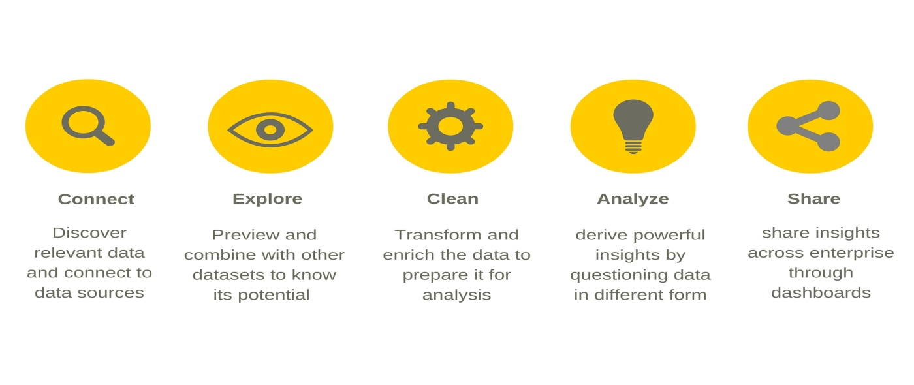

**3.2 DATASET SELECTION**

For this research we have used six datasets. All are from Open Government Data (OGD) Platform India (data.gov.in).

1. Crime against Women during 2001-2012
2. World crime against women statistics
3. District-wise crimes committed against Women during 2001-2012
4. Age and sex wise persons arrested under crime against women during 2012
5. Persons arrested under crime against Women during 2001-2012.
6. USA rape statistics 2000-2015
7. Json files for world maps

Datasets 1 is contributed by Ministry of Home Affairs, Department of States, National Crime Records Bureau (NCRB). Datasets 3 and 5 are contributed by Ministry of Home Affairs,

Department of States, National Crime Records Bureau (NCRB).

**3.3 EXPLORATORY DATA ANALYSIS (EDA)**

Exploratory Data Analysis (EDA) is an approach/philosophy for data analysis that employs a variety of techniques (mostly graphical) to

* Maximize insight into a data set
* Uncover underlying structure
* Extract important variables
* Detect outliers and anomalies
* Test underlying assumptions
* Develop parsimonious models
* Determine optimal factor settings.

Most EDA techniques are graphical in nature with a few quantitative techniques. The reason for the heavy reliance on graphics is that by its very nature the main role of EDA is to open-mindedly explore, and graphics gives the analysts unparalleled power to do so, enticing the data to reveal its structural secrets, and being always ready to gain some new, often unsuspected, insight into the data.

**3.4 DATA CLEANING**

Data cleaning is the process of preparing data for analysis by removing or modifying data that is incorrect, incomplete, irrelevant, duplicated, or improperly formatted. This data is usually not necessary or helpful when it comes to analyzing data because it may hinder the process or provide inaccurate results. The nulls of the dataset will be removed so that we may get accurate predictions. Predictive analysis must be done on cleaned data to get the most accurate results.

**3.5 PREDICTIVE ANALYSIS**

Predictive analytics is the practice of extracting information from existing data sets in order to determine patterns and predict future outcomes and trends. Since the data that we have are labelled and structured, we have decided to use linear regression prediction methods to calculate the future crime rates against women with time.

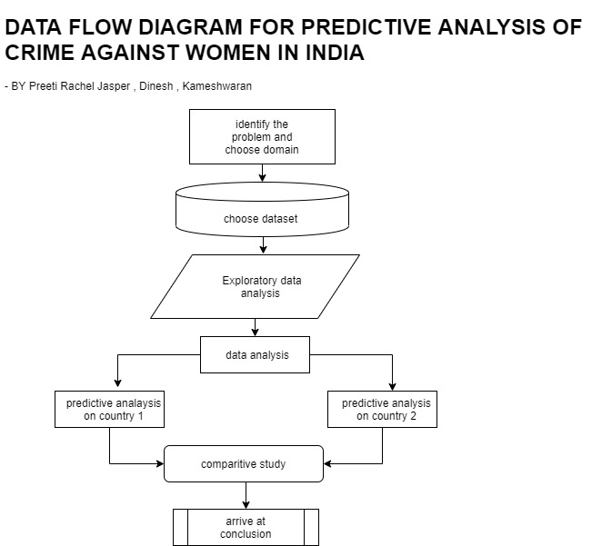

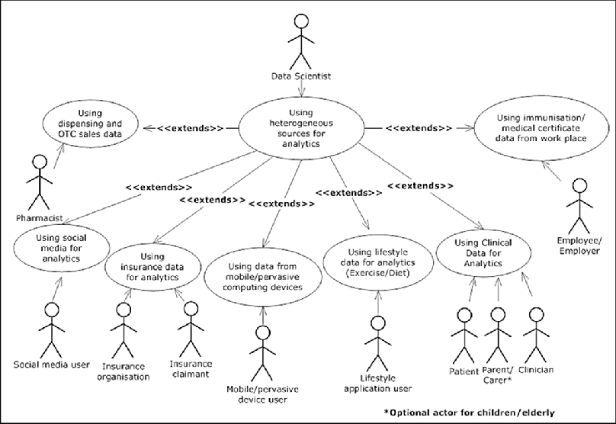

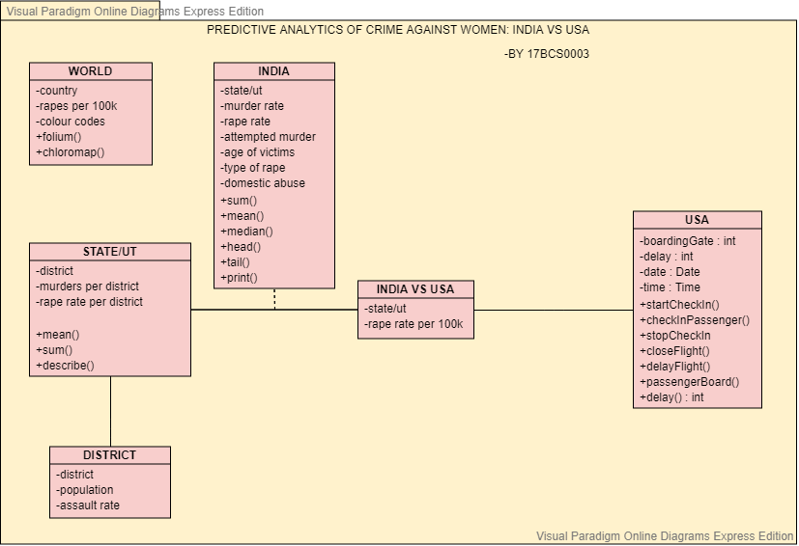

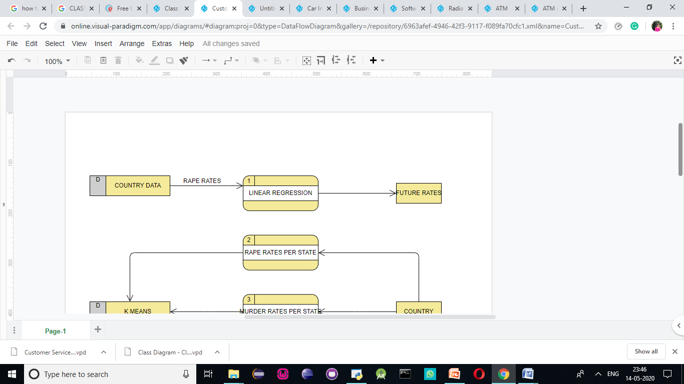

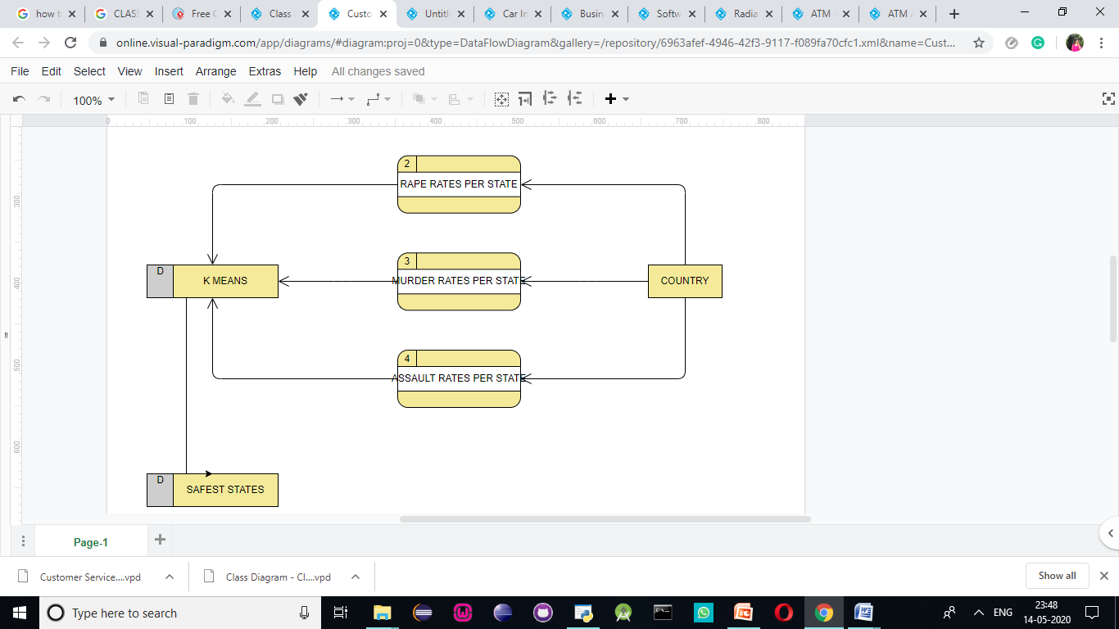

**3.7 LINEAR REGRESSION USED FOR PREDICTIVE ANALYSIS**

Data analysts often use a linear relationship to predict the (average) numerical value of Y for a given value of X using a straight line (called the regression line). If you know the slope and the y-intercept of that regression line, then you can plug in a value for X and predict the average value for Y. In other words, you predict (the average) Y from X.

Simple linear regression makes use of the formula y= mx +c. By calculating the values of the slope and Y-intercept, we can predict the value of the dependent variable using the known values of the independent variable.

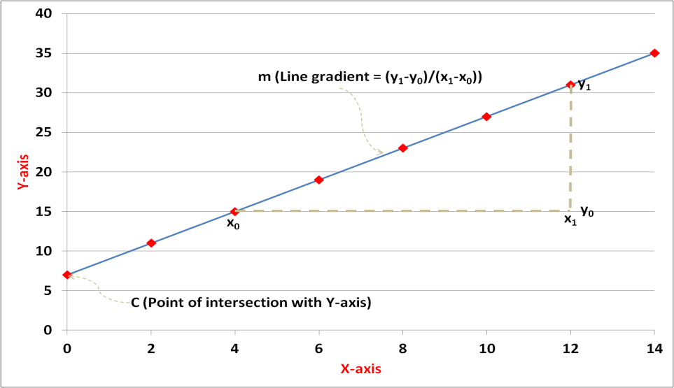

**Chapter 4**

**Implementation**

**III.I COLLECTION OF DATA SET**

**INDIA**

The data collected is imported to the notebook. Using the pandas library the csv file is imported and ready for use.

Now, by using df.head() function, by default the first five rows can be seen.

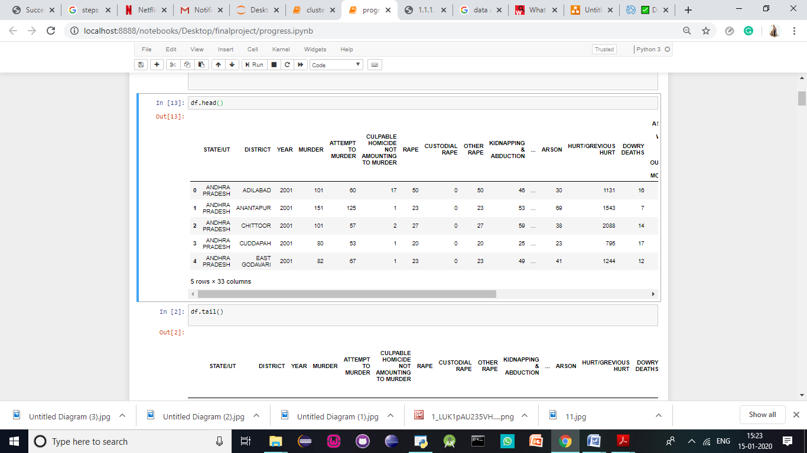

Now, by using the df.tail() function the last five rows are seen. These functions are used to make sure the csv file has been imported correctly.

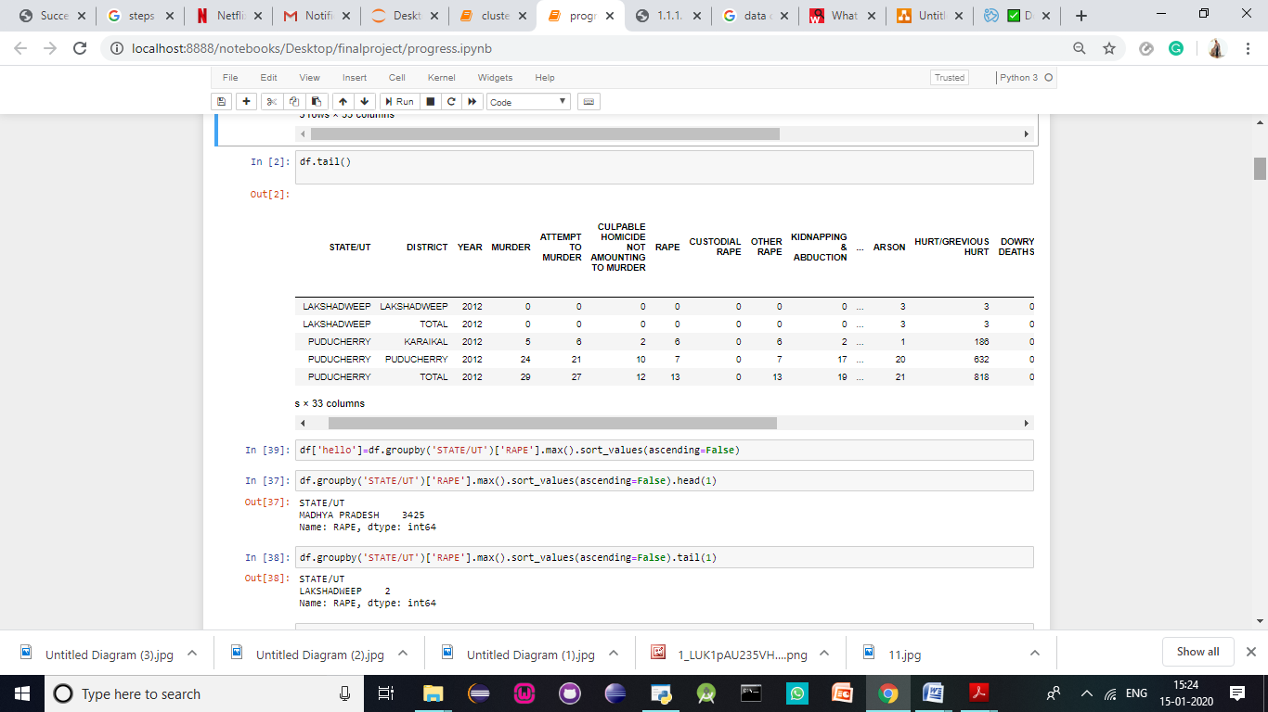

Now, while performing EDA, we find the state which has the most number of reported sexual assaults against women below.

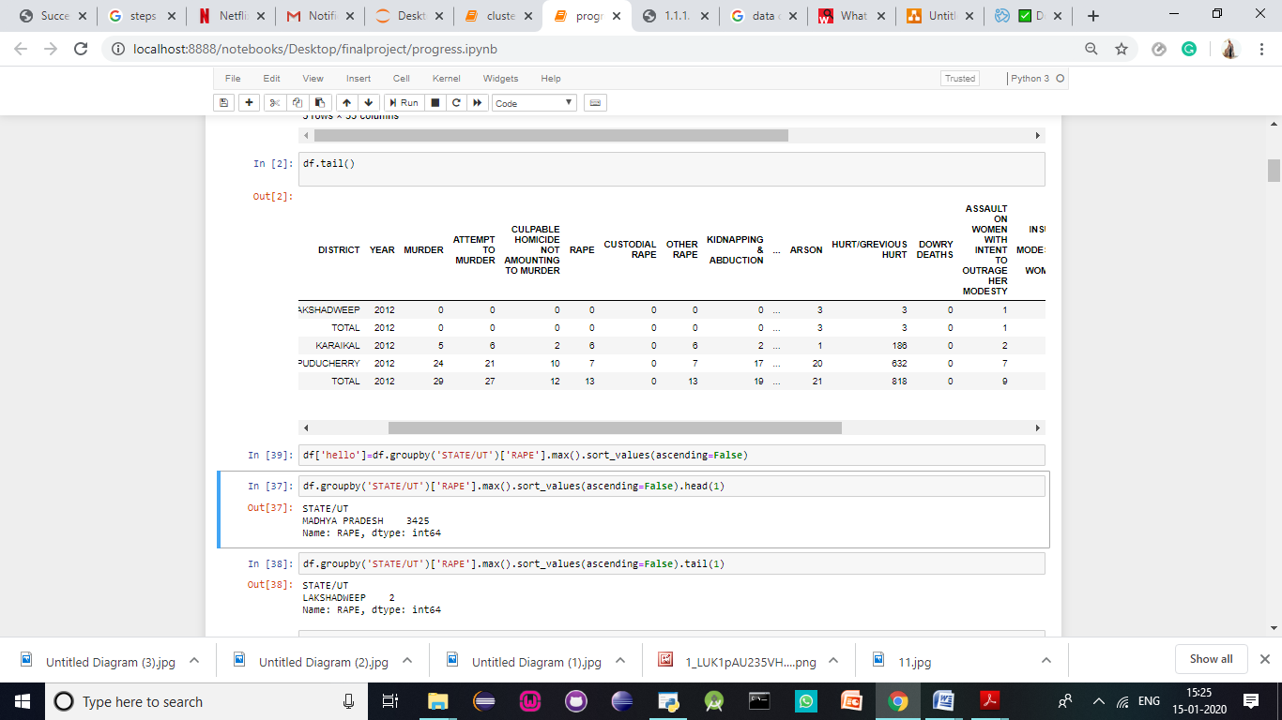

Then we find the state which has the lowest number of sexual assaults.

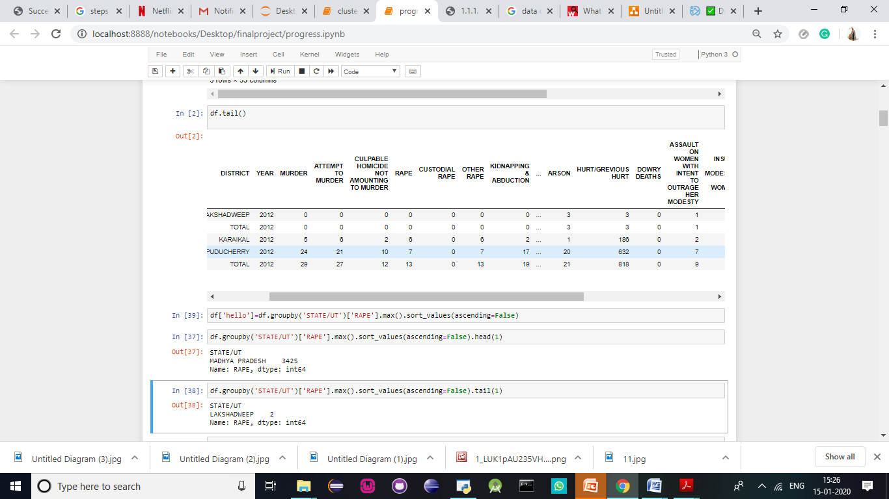

The null values are replaced with ‘’ and then the sum of null values is calculated to find the sum of null values.

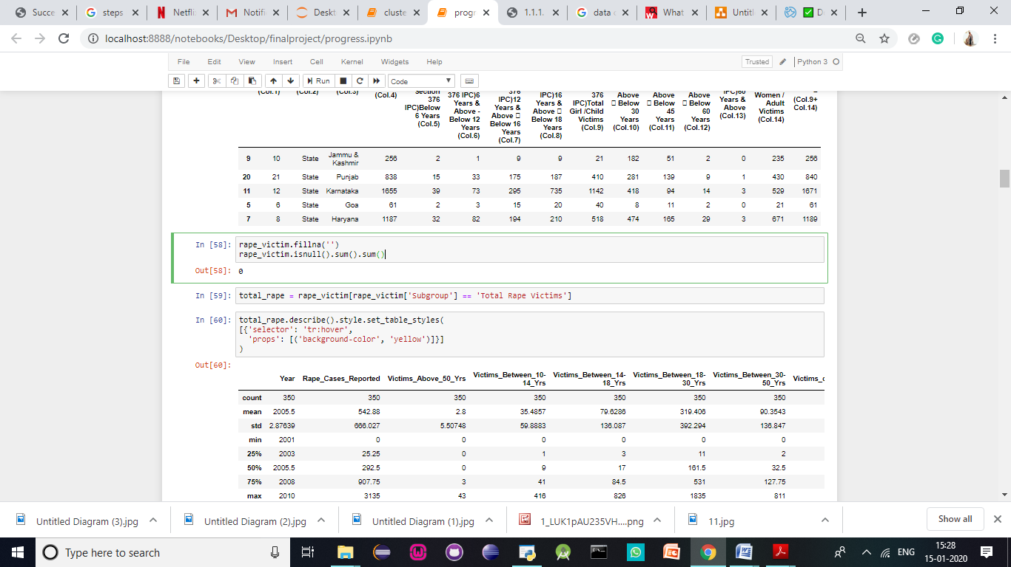

Correlogram of the input variables

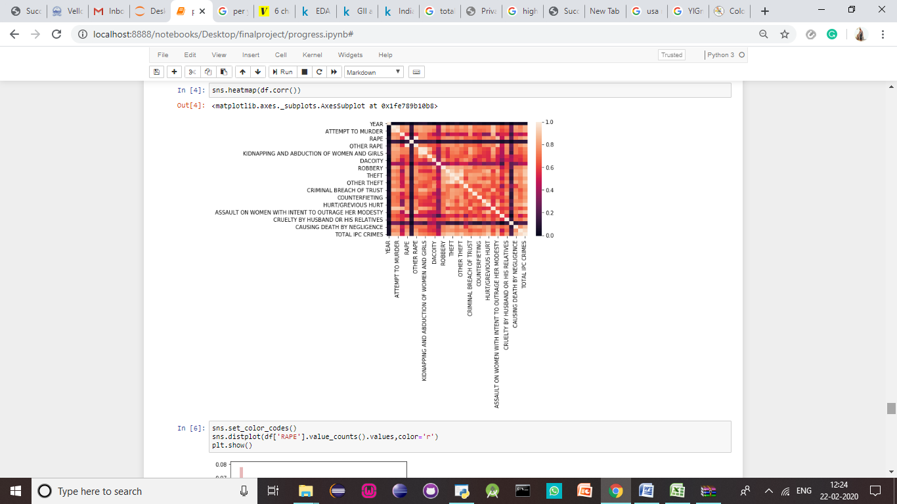

Boxplot of the rape statistics vs year

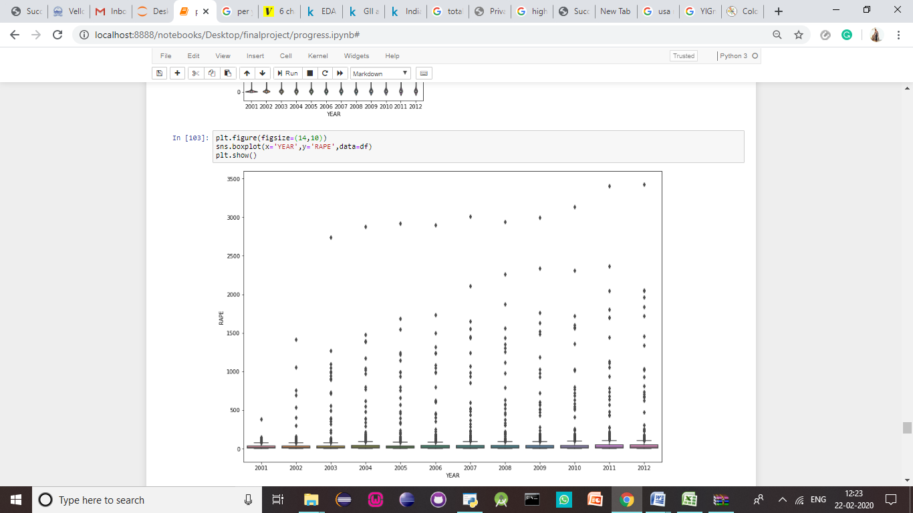

Now, we use python to find and visualize the line graph showing the condition of the country over the past decade. One can see a considerable raise in the number of crimes reported over the decade.

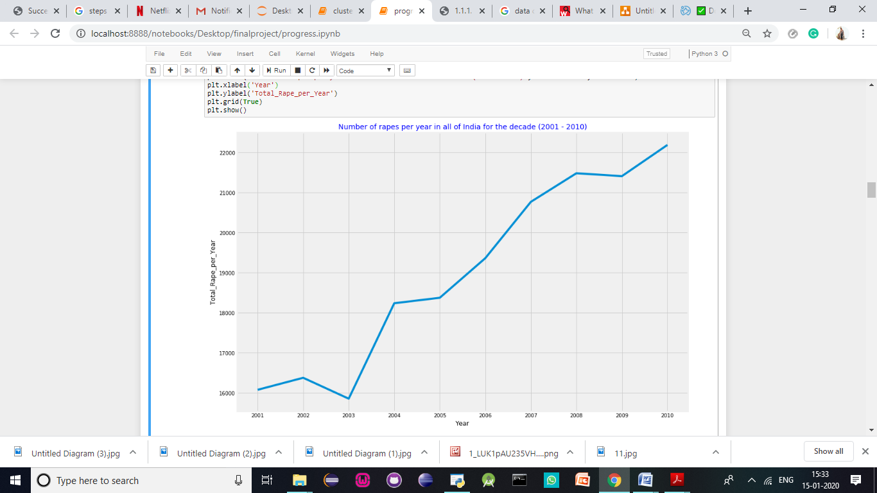

The folium library is used to visualize the crime data against women per capita. This shows that the per capita rates in India are low. This supports the hypothesis that the population spurt in India over the decade could be the reason. The code is written the visualise the .json file for better understanding.

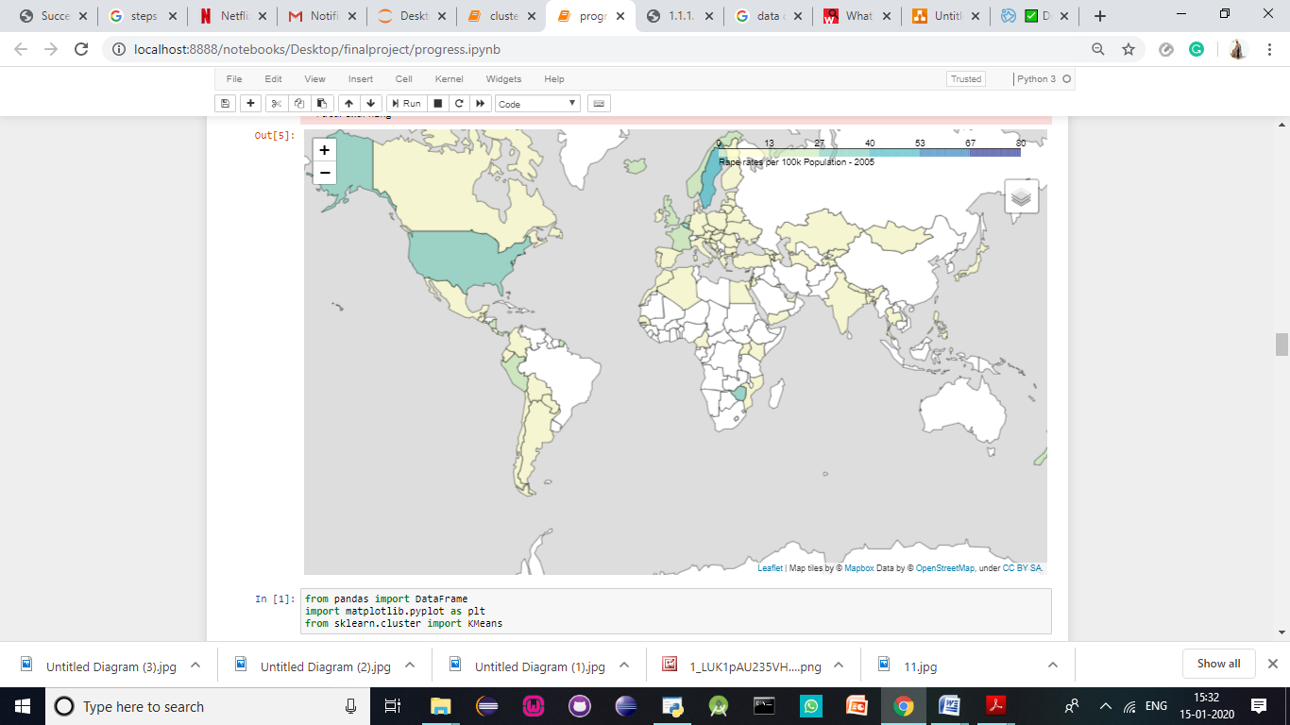

We find that India has one of the lowest crime rates against women per capita

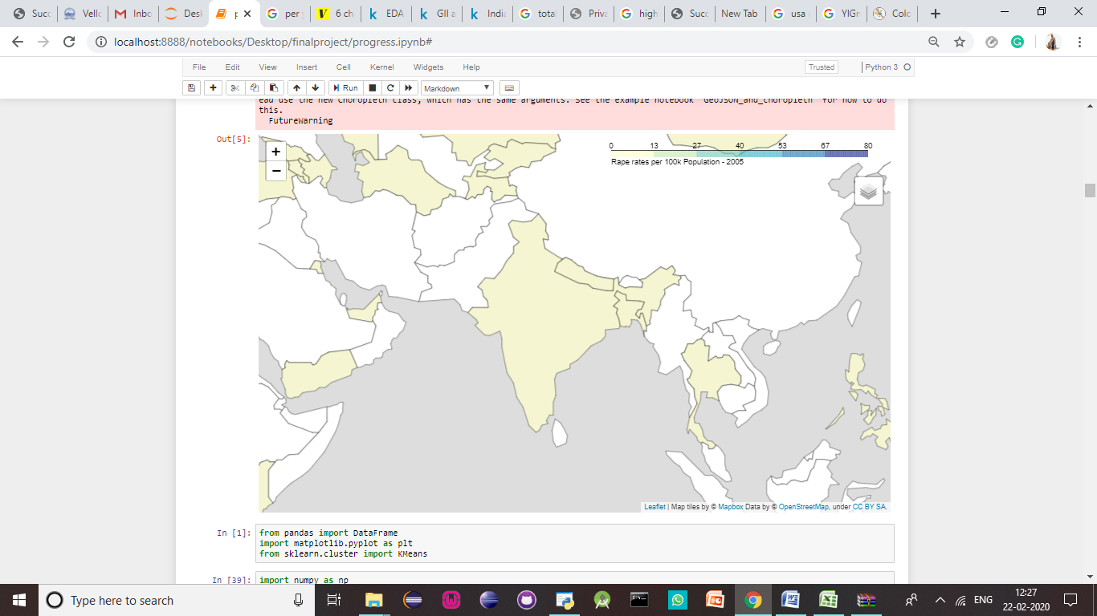

Now the data is cleaned and normalized. From the csv file, the total data is deleted and then the data is normalized. The code for normalization is done using the MinMaxScaler. The df_normalized attributes are seen below.

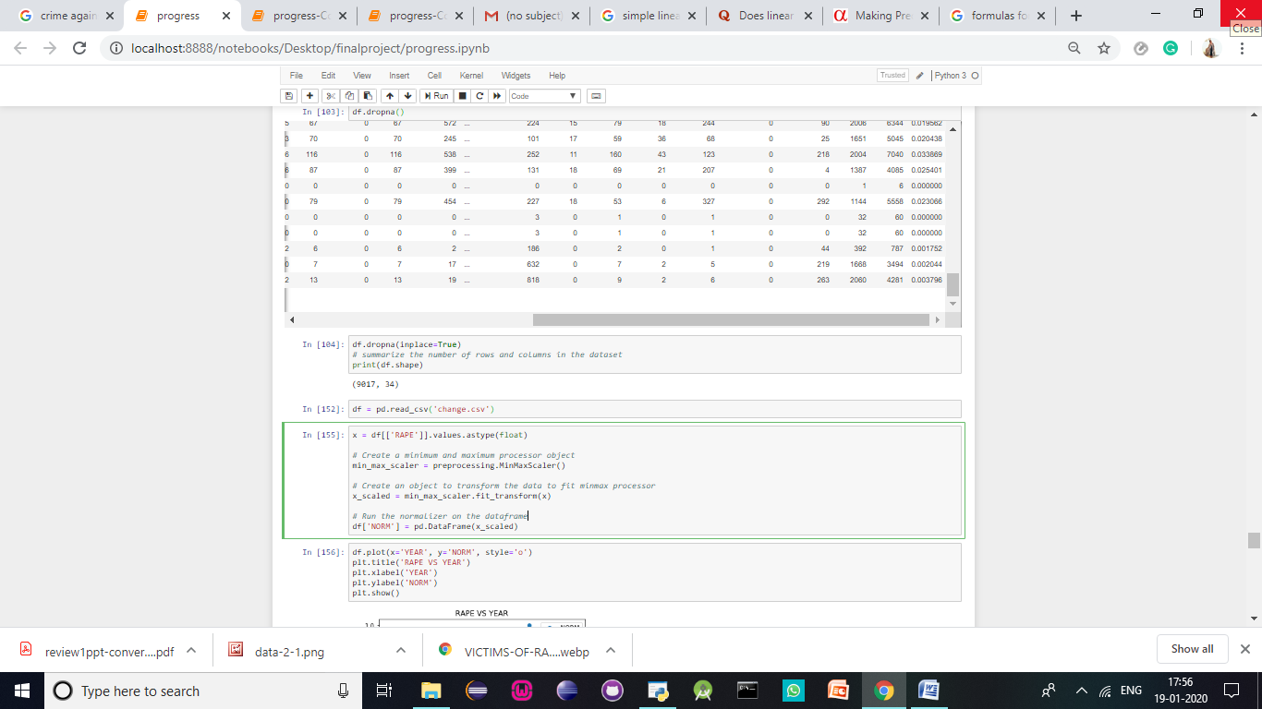

Now, the data is cleaned and ready for analysis

**Linear Regression:**

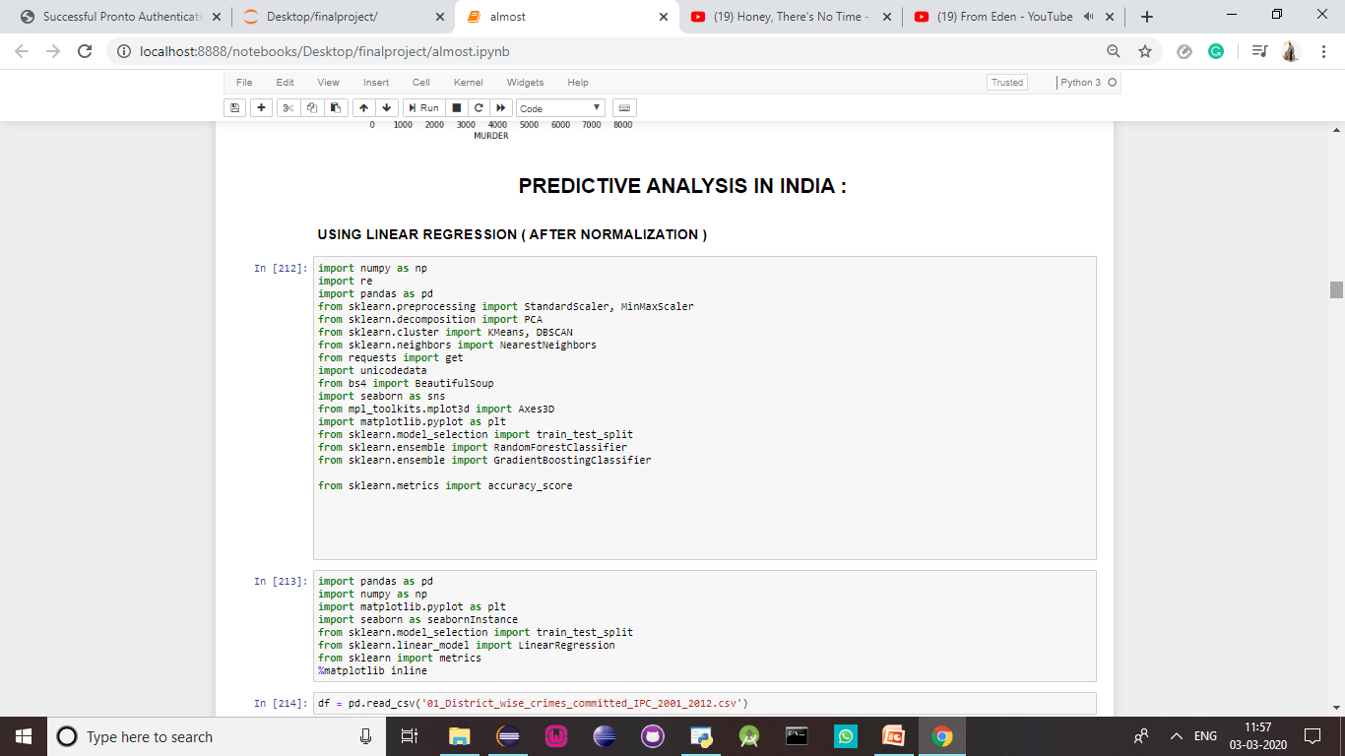

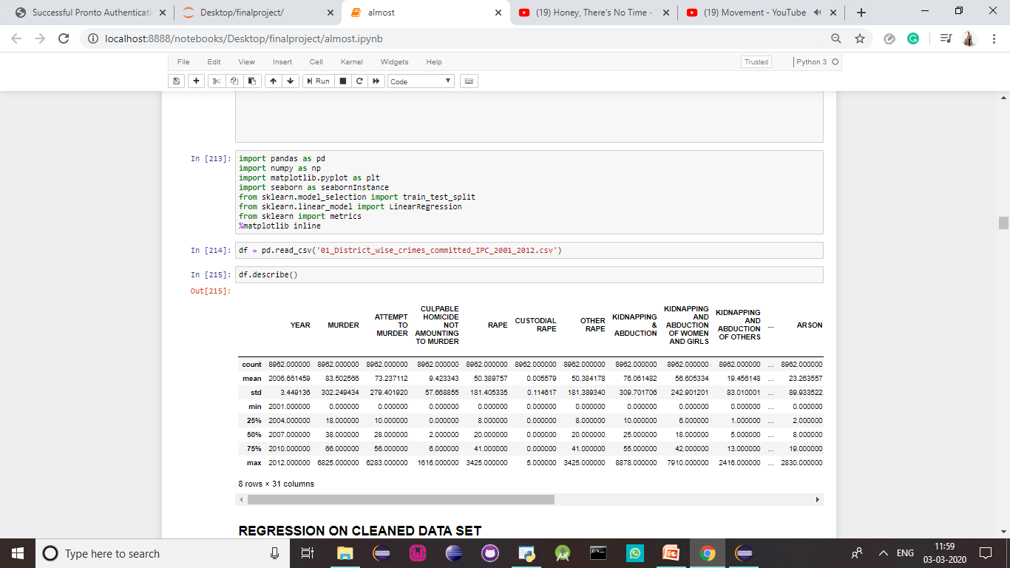

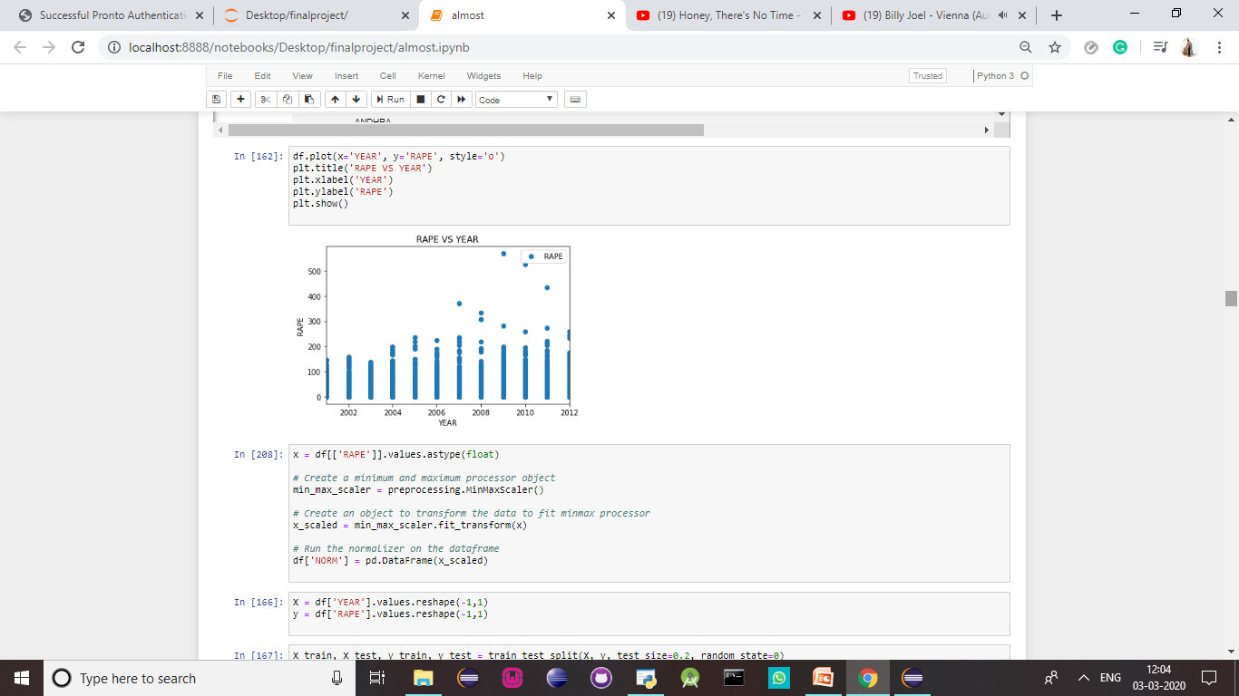

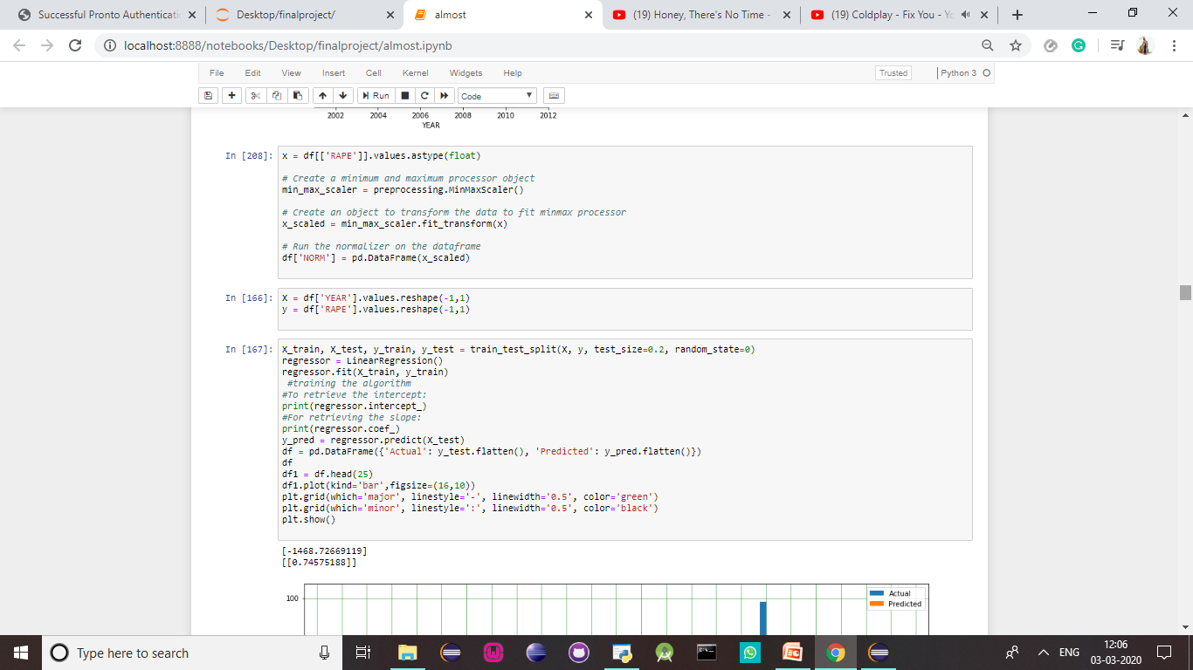

This is the Y-intercept and the slope. Now lets look at the graph that shows the actual and predicted values:

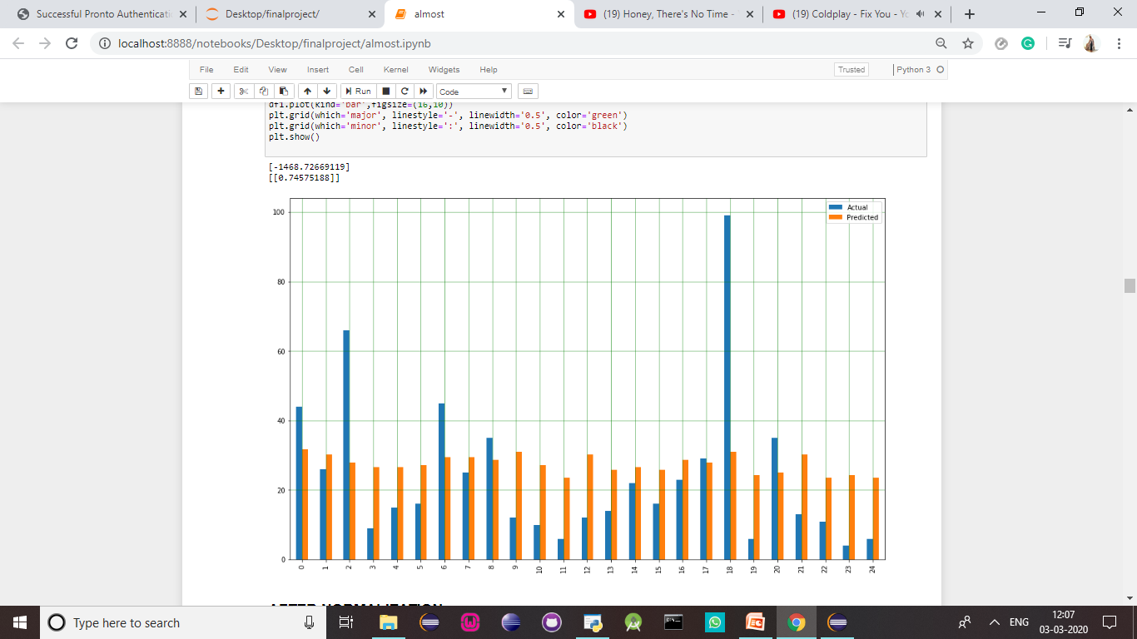

Now lets perform normalization so that we can perform result analysis:

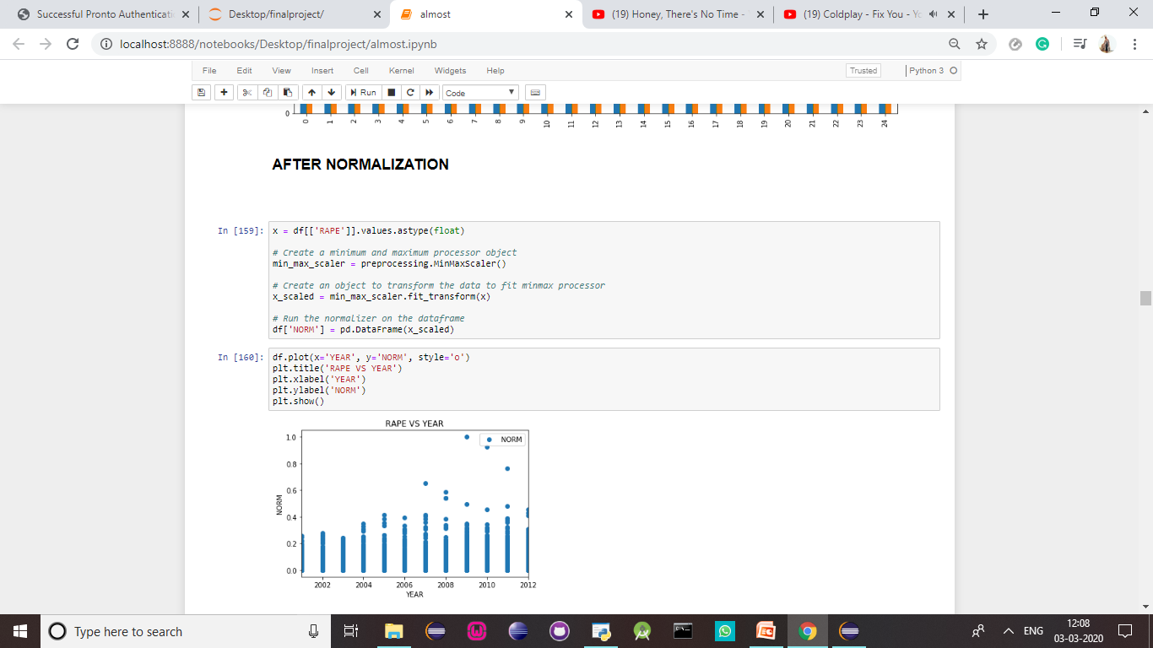

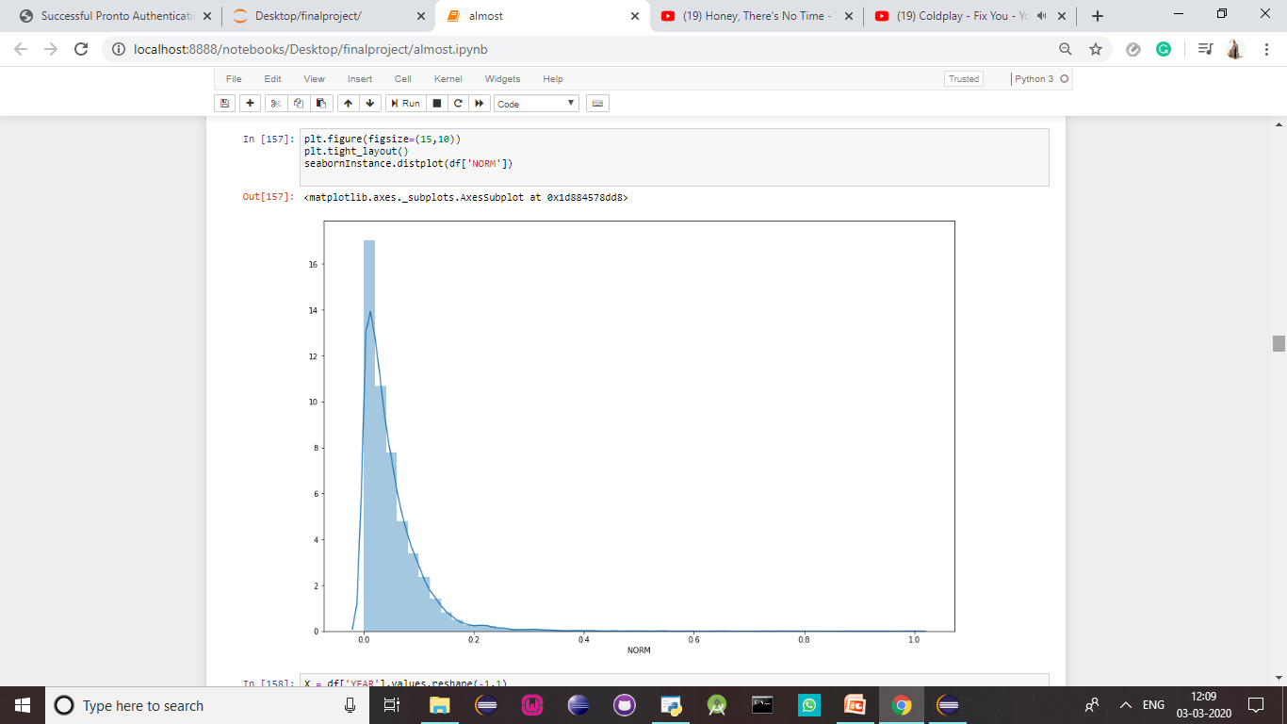

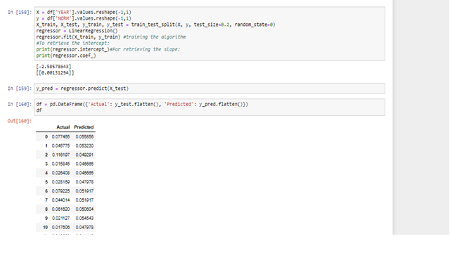

This data has been cleaned for better results



**RESULT ANALYSIS**

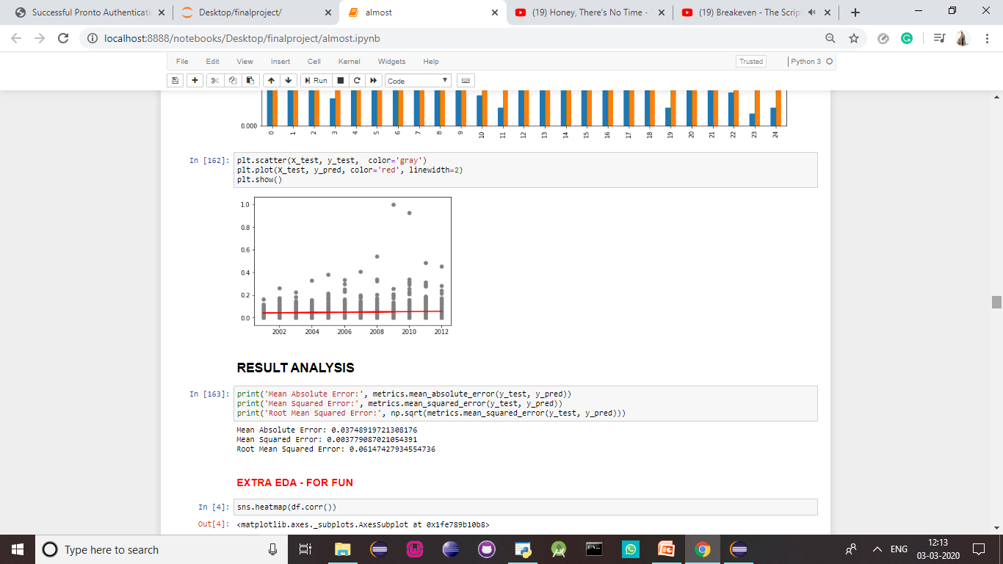

From the analysis now we can find that the algorithm will give an average of 35 cases of rape in India.

**USA**

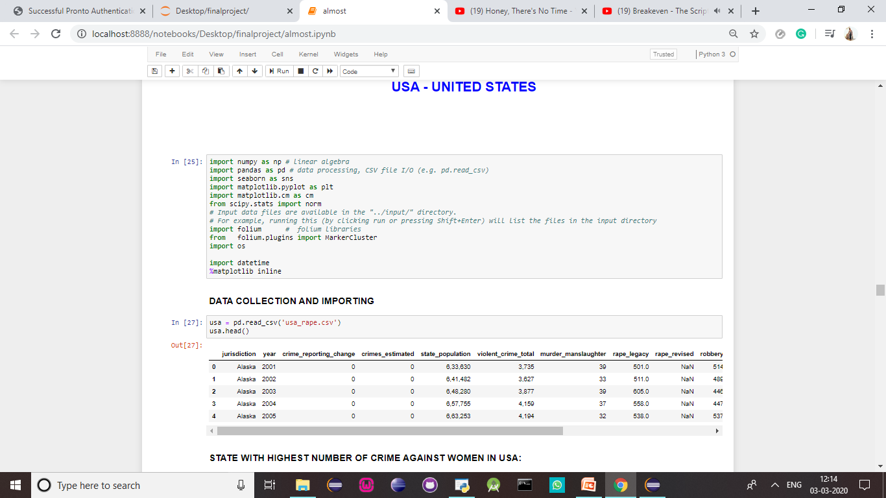

. 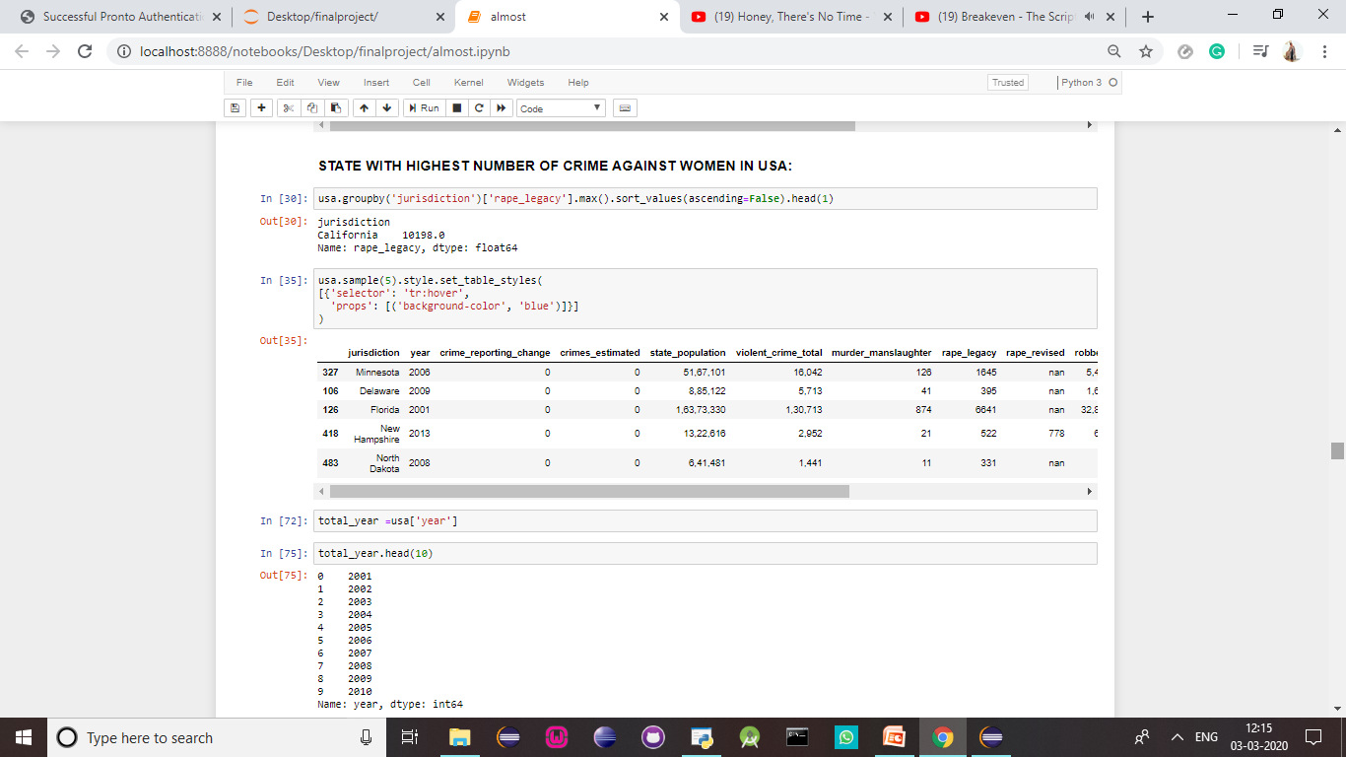

This is the graph showing you the number of crimes against women in USA over the decade:

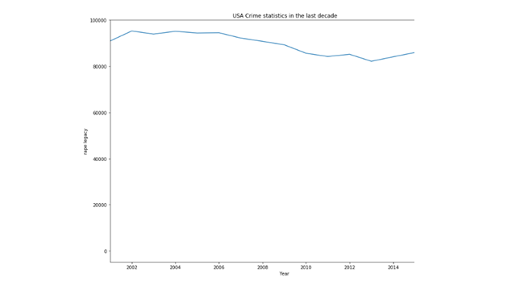

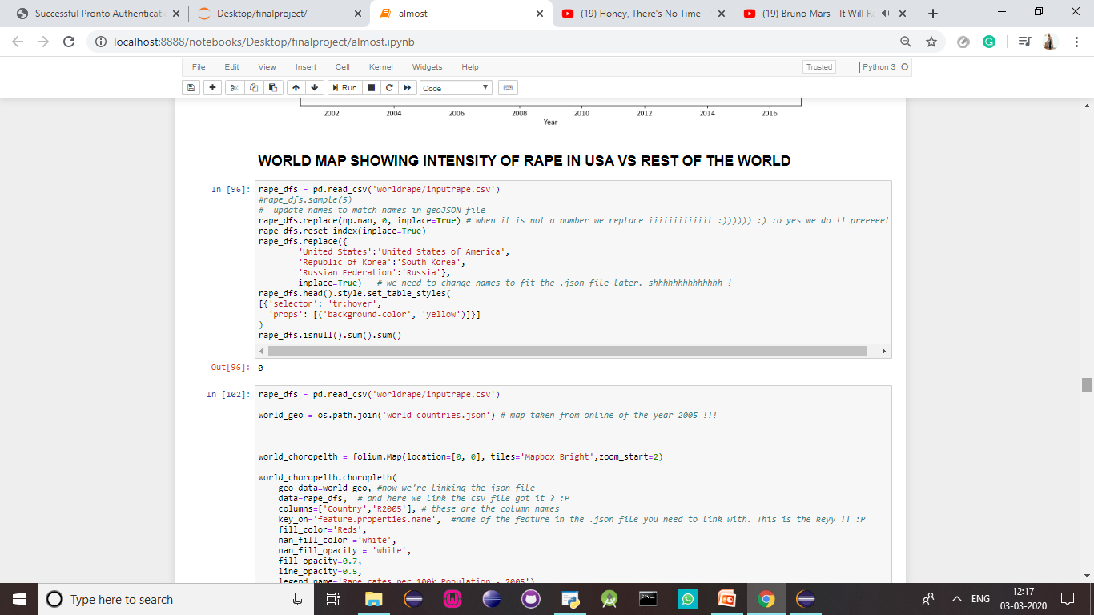

We can see that USA has one of the highest number of rapes in the world:

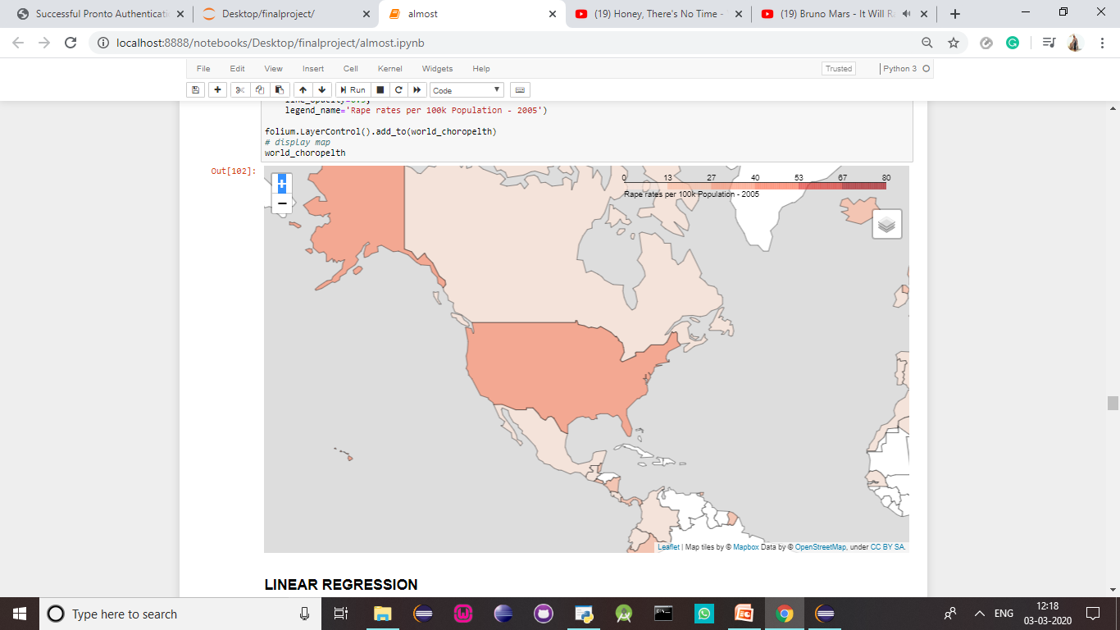

**Predictive analysis of crimes against women in USA**

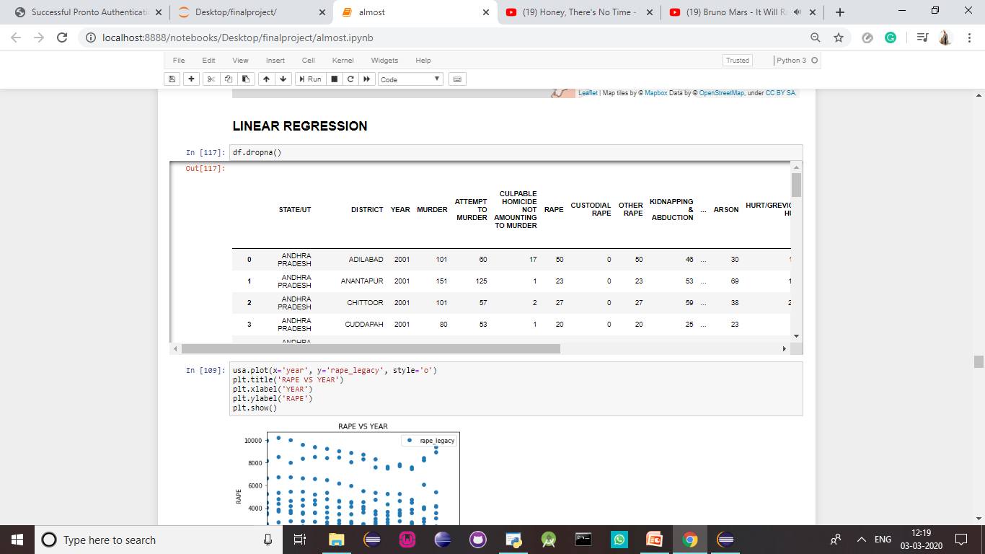

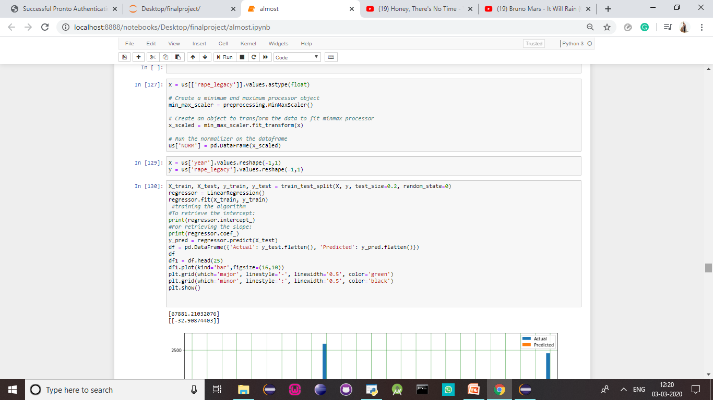

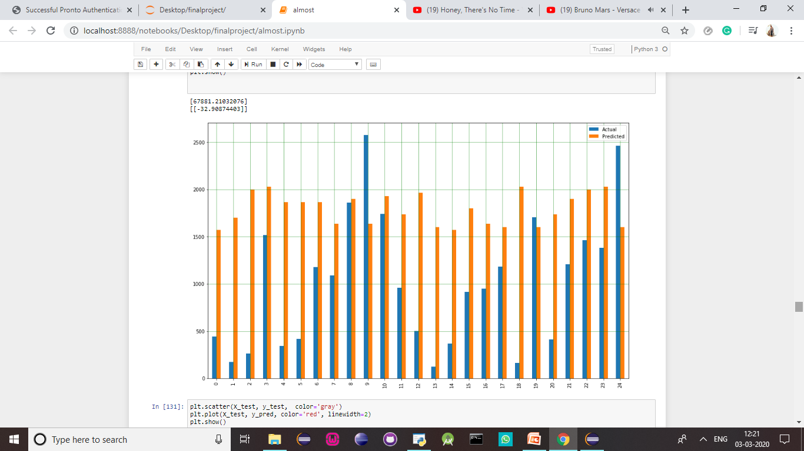

You can see that the regression line is now plotted based on the predicted values:

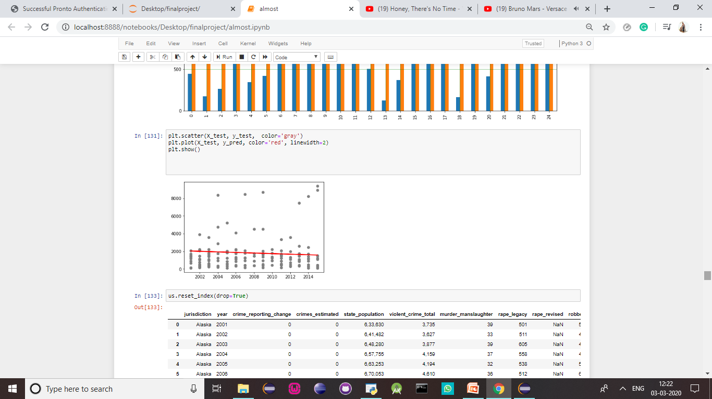

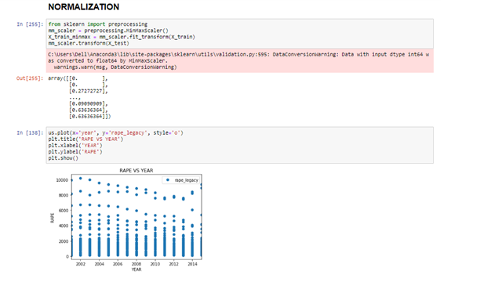

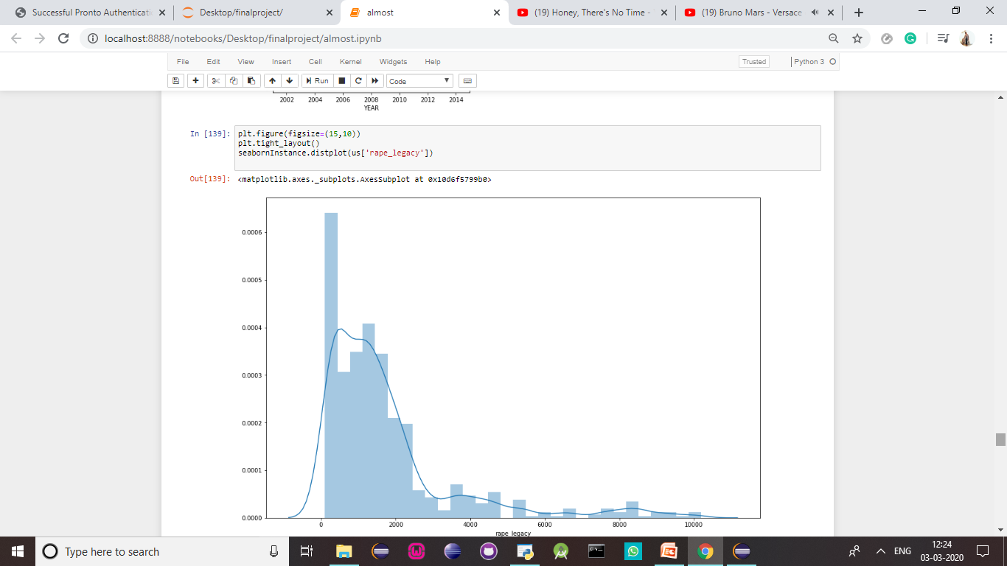

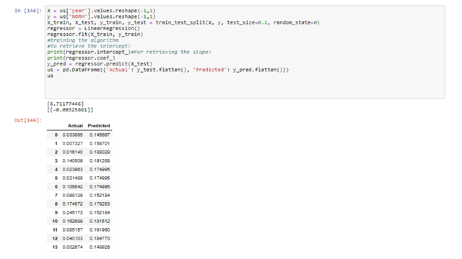





**TEAM NUMBER – 1**

**Name:** PREETI RACHEL JASPER



**Register Number:** 17BCS0003

**Date of Birth:** 19/12/1997

**Blood Group:** B+ve

**Phone Number:** 9003306860

**Email:** preetirachel.jasper2017@vitstudent.ac.in

**Address:** BETHELS, TRA C6, TC 26/2139,

STATUE ROAD, TRIVANDRUM-1

**Pin Code:** 695001

TEAM NUMBER – 2

Name :

Passport size photo (Recently Taken one)

Register Number:

Date of Birth:

Blood Group:

Phone Number:

Email:

Address: *(full address with pin code)*

TEAM NUMBER – 3

Name :

Passport size photo (Recently Taken one)

Register Number:

Date of Birth:

Blood Group:

Phone Number:

Email:

Address: *(full address with pin code)*